**Vector Surveillance**

Complete the General Survey Information section.

Planning Section: Find your target vector, answer questions as they appear

Sampling Results: use the + icon to add results

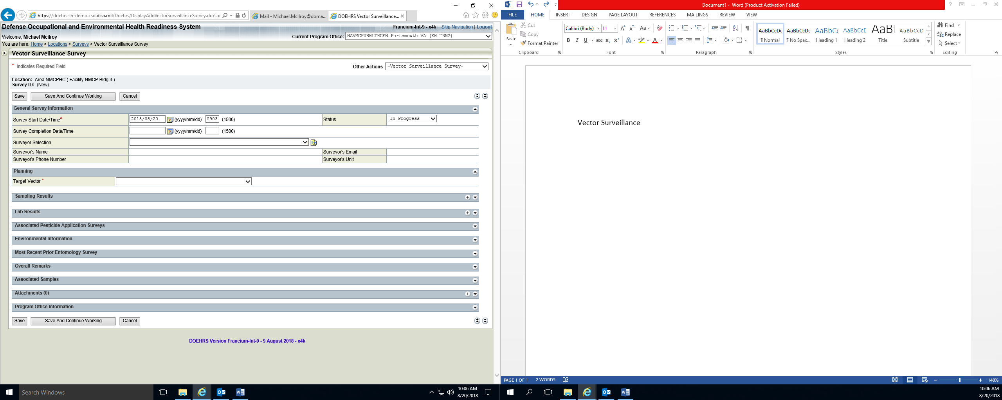

Complete sampling results. Click Save

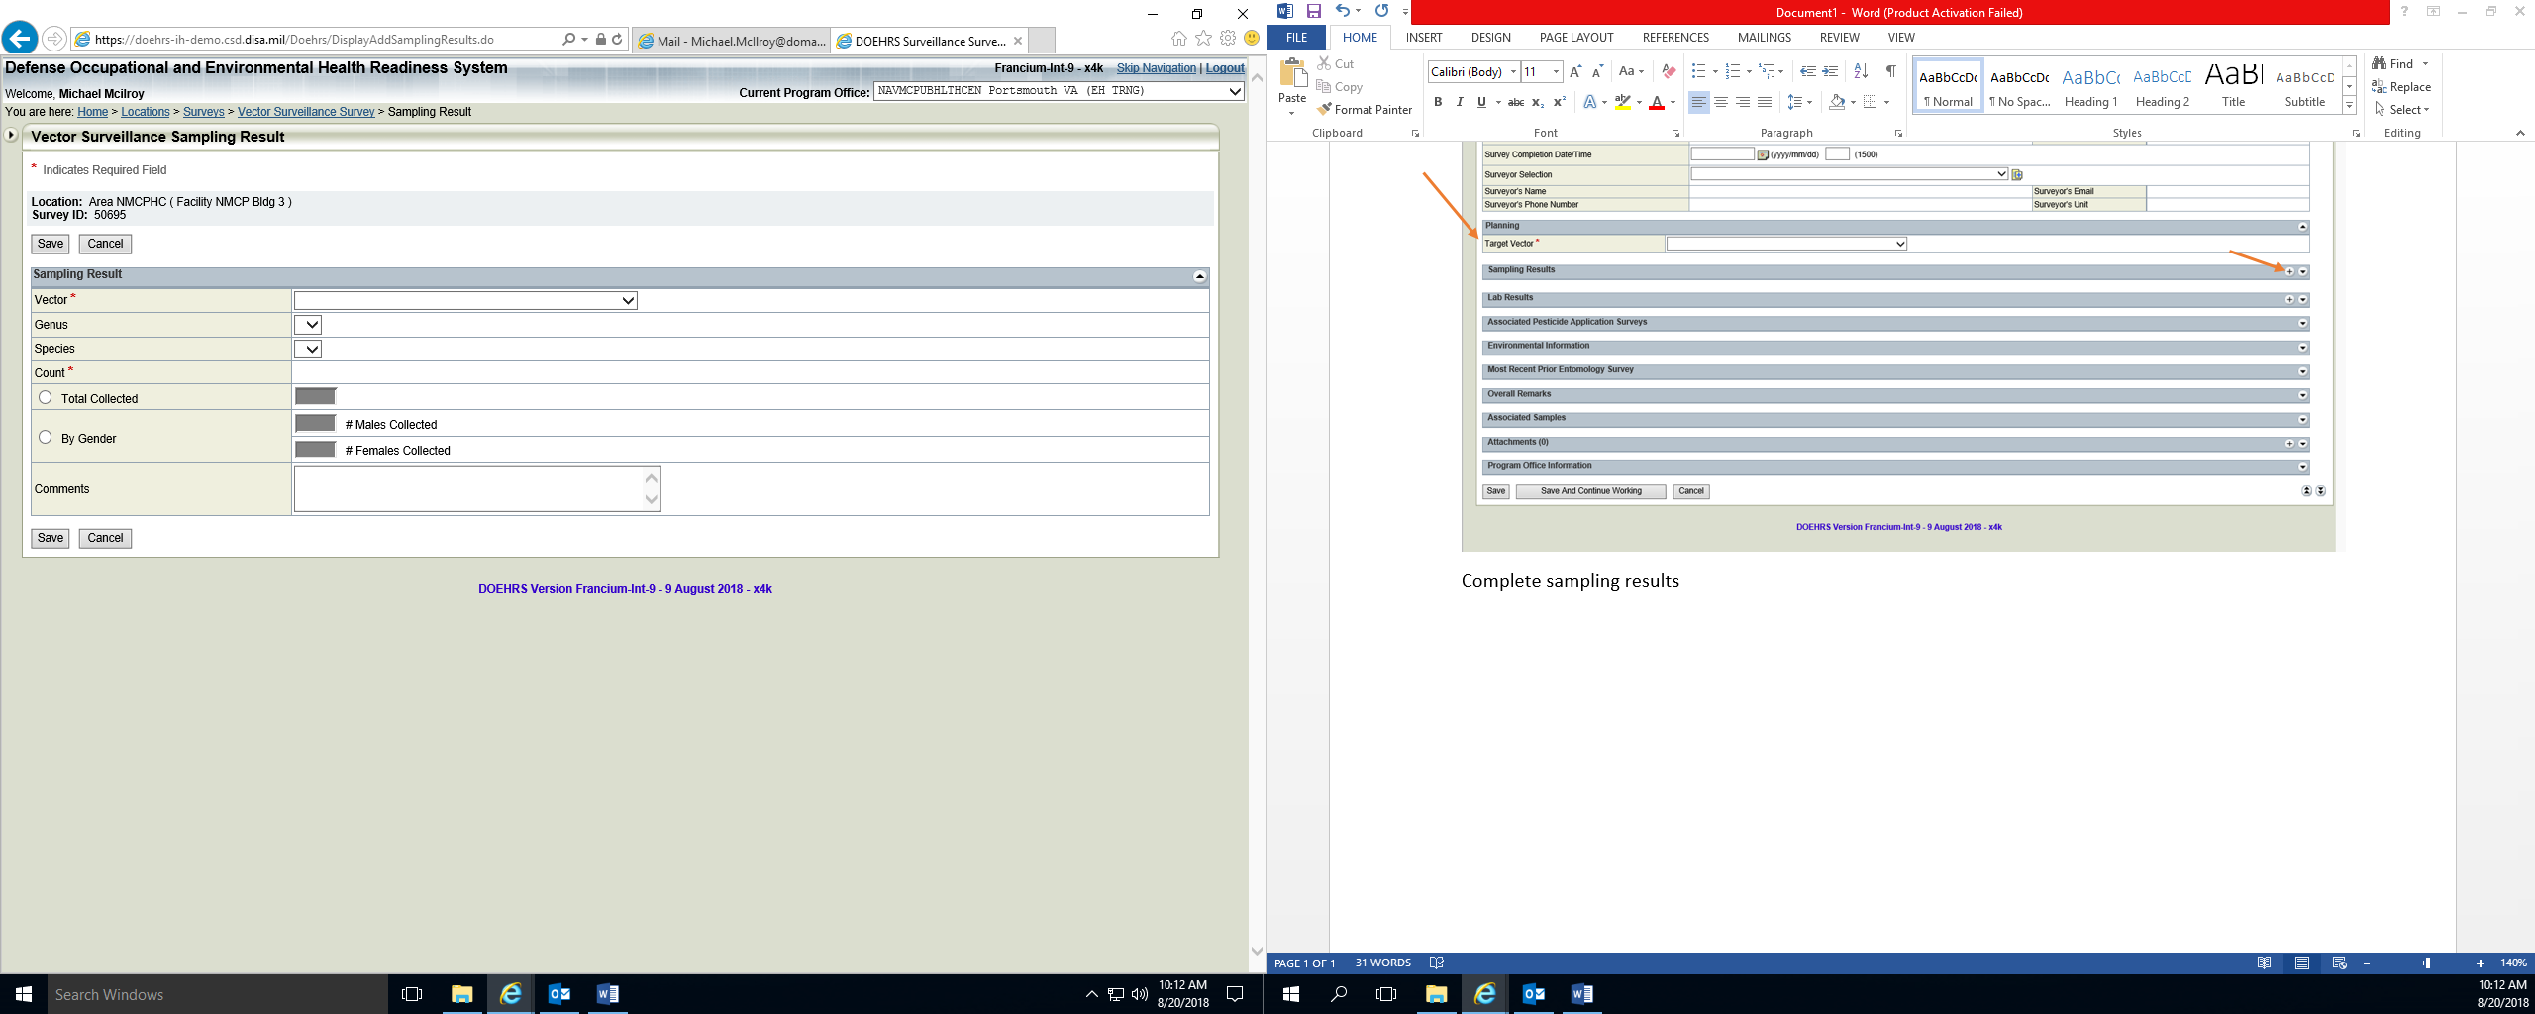

If you have documents or sample counts they should be added as an attachment. (This completes the Vector Survey)